

Short Exam 2 – Computer Vision 2022

1 h 30 – No document allowed – The exam will be graded on 20 points.

Part 1 (5 points - 20 mns): Triangulation (from Exam 2021)

Two cameras are looking at the same scene. The projection matrices of the two cameras are P1 and P2. They see the same 3D point X = (X; Y; Z)^{T}. The observed coordinates for the projections of point X are x1 and x2 in the two images, respectively. The numerical values are as follows:
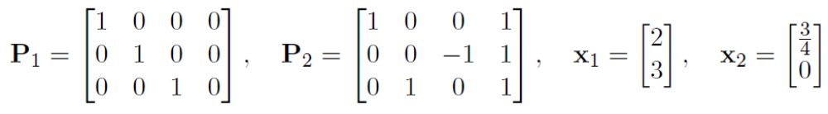

Question 1 (1 point): Compute the 3D coordinates of the point X. (Hint: Perhaps the simplest way in this case is to write the projection equations in homogeneous coordinates by explicitly writing out the unknown scale factors, and to solve X; Y; Z and the scale factors directly from those equations.)

Ans:
As s₁ x₁ = P₁ X we get s₁ X = 2 (1); s₁ Y = 3 (2) and s₁ Z=1 (3)
As s₂ x₂ = P₂ X we get s₂ (X+1) = ¾ (4); s₂ (-Z+1) = 0 (5) and s₂ (Y+1)=1 (6)

We have 6 equations with 5 unknowns, after eliminating Y and Z we obtain s2/s1=4, after eliminating X we obtain s2=1/4.
So X=2; Y=3; Z=1 ; s1= 1; s2 = 1/4.

Question 2 (2 points): Present a derivation for the linear triangulation method and explain how X can be solved using that approach in the general case (i.e. no need to compute with numbers in this subtask).

Ans: thanks to the epipolar constraint we have another set of equations
x₁ = P₁ X and x₂ = P₂ X (2+1 equations for each corresponding points)
x₂^{T} F x₁ = 0 (with rectified image the search space is reduced to 1 dimension)
with a correlation method another equation can be defined to solve X

Question 3 (1 point): A third camera P3 is added to the scene. Describe how the linear triangulation method above can be extended to use the information from all the three
cameras.

Ans: See the process described in Part 1 of TD3_Computer_Vision_2021

Question 4 (1 point): If there is noise (i.e. measurement errors) in the observed image coordinates of point X, the linear triangulation method above is not the optimal choice but a nonlinear approach can be used instead. What error function is typically minimized in the nonlinear approach?

The correlation method is an example of nonlinear approach. One error function consists to minimize local incoherencies related to the depth estimation through a local smoothing criterion such as the one illustrated below:

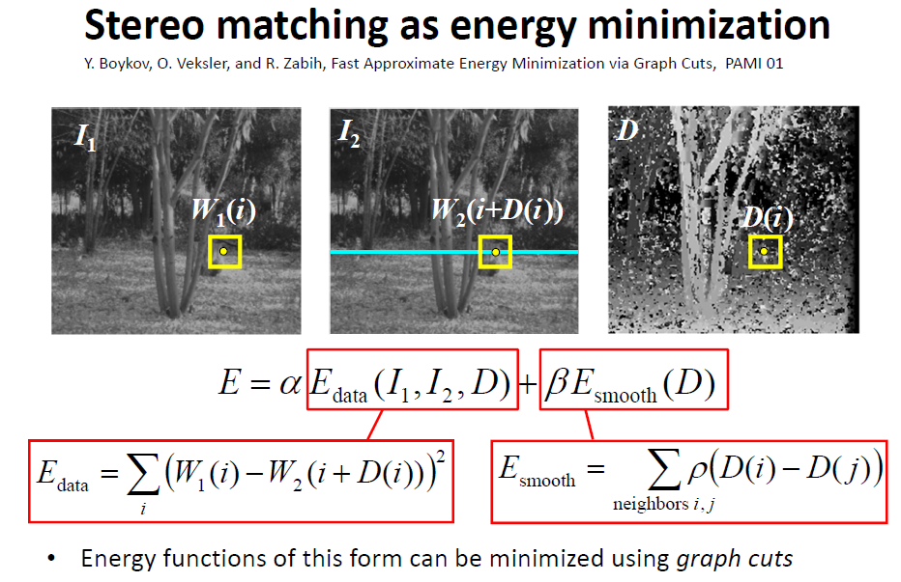

Part 2 (7 points - 40 mns): Geometric 2D transformations

Question 1 (3 points): Using homogeneous coordinates, write the matrix form of the following 2D transformations: translation, similarity (rotation+scaling+translation), affine and homography. How many degrees of freedom does each transformation have? How many point correspondences are needed to estimate each?

Ans: with 2 equation per point correspondence with need

Translation 2DOF (see slide 12 of linear algebra course from TUM) - 1 point correspondence

x’ 1 0 T_{x} x
y’ = 0 1 T_{y} y
1 0 0 1 1

Similarity 4DOF (see slide 22 of linear algebra course from TUM) - 2 points correspondence

x’ s cos(θ) -s sin(θ) T_{x} x
y’ = s sin(θ) s cos(θ) T_{y} y
1 0 0 1 1

Affine 6DOF (see slide 23 of linear algebra course from TUM) - 3 points correspondence

x’ a1 a2 T_{x} x
y’ = a3 a4 T_{y} y
1 0 0 1 1

Homography 9DOF (see slide 25 of linear algebra course from TUM) - 5 points correspondence

x’ a1 a2 T_{x} x
y’ = a3 a4 T_{y} y
1 b1 b2 b 1

A similarity transformation consists of rotation, scaling and translation and is defined using conventional Cartesian coordinates as follows:

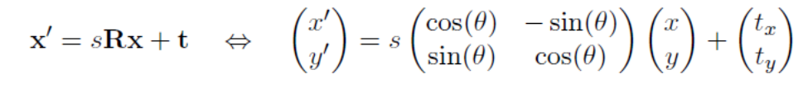
Question 2 (4 points): Describe a procedure for solving the parameters:
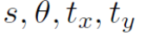
of a similarity transformation from two point correspondences
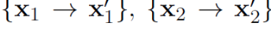

Use the procedure to compute the transformation from the following point correspondences:

(Hint: Drawing the point correspondences on a grid paper may help you to check your answer.)

Ans: for a similarity transformation we have

x₁’ = s cos(θ) x₁ - s sin(θ) y₁ + T_{x} ₍₁₎
y₁’ = s sin(θ) x₁ + s cos(θ) y₁ + T_{y} ₍₂₎

x₂’ = s cos(θ) x₂ - s sin(θ) y₂ + T_{x} ₍₃₎
y₂’ = s sin(θ) x₂ + s cos(θ) y₂ + T_{y} ₍₄₎

x₁’, y₁’, x₂’, y₂’ are known
s, θ, T_{x,} T_{y} are unknown

from ₍₁₎ ₋ ₍₃₎ we have:
(x₁’ – x₂’) = s cos(θ) (x₁ – x₂) - s sin(θ) (y₁ – y₂) ₍₅₎

from ₍₂₎ ₋ ₍₄₎ we have:
(y₁’ – y₂’) = s sin(θ) (x₁ – x₂) + s cos(θ) (y₁ – y₂) ₍₆₎

from ₍₅₎ we have:
(x₁’ – x₂’) / (x₁ – x₂) + s sin(θ) (y₁ – y₂) / (x₁ – x₂) = s cos(θ) ₍₇₎

from ₍₆₎ we have:
(y₁’ – y₂’) / (y₁ – y₂) - s sin(θ) (x₁ – x₂) / (y₁ – y₂) = s cos(θ) ₍₈₎
from _{(7) and (8)} we can estimate : s sin(θ)

then from ₍₇₎ we can estimate : s cos(θ)

then from ₍₁₎ we can estimate : T_{x}
and from ₍₂₎ we can estimate : T_{y}

from s sin(θ) and s cos(θ) we can estimate s, next θ
y

x

x
x
x
x
(1/2, 0)
x

|| v|| = sqrt(½² + ½²) = 1/2 sqrt(2)

y'

x

x
x
x
x
(0, 0)
x'
x
x

x
(-1, -1)

|| v’|| = sqrt(1 + 1) = sqrt(2) = 2x || v||

That means that s = 2

From previous equations we obtain s sin(θ) =2 (from (7)), next s cos(θ)=0, this implies that cos(θ) = 0 and consequently θ= 90° and sin(θ) =1 (This is coherent with the blue arrow shown above), and prove that s=2.

From previous equations we obtain T_{x =} 0 (from (1) and T_{y =} -1 (from (2))

Part 3 (9 points - 30 mns): Epipolar Geometry and Stereo

Consider the following top view of a stereo rig:
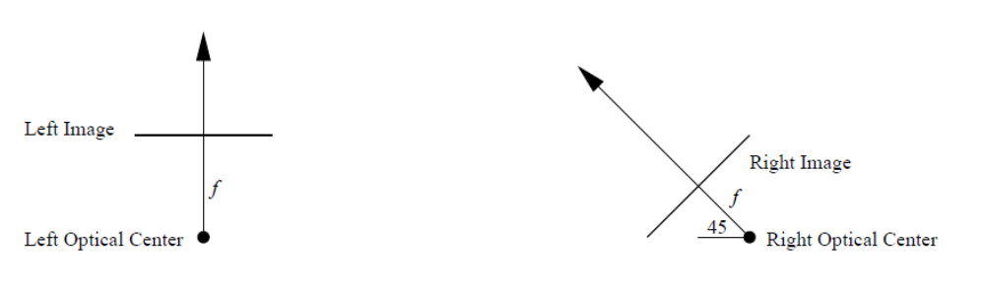

Question 1 (3 points): Draw the front views of the two 2D images and show (and clearly label) the approximate positions of the epipoles and epipolar lines for this configuration of cameras.

Ans: x Q
x P

x
x

x x

x
z

q
x
x
x
q
y
x
p
p

x

Parallell epipolar lines (e at the infinity) Epipolar lines intersect on e

Question 2 (2 points): Given a conjugate pair of points, at pixel coordinates p = (xl , yl) in the left image and at pixel coordinates q = (xr , yr) in the right image of a stereo pair, give the equation that describes the relationship between these points when neither the intrinsic nor extrinsic parameters of the cameras are known. Also specify how many conjugate pairs of points are needed to solve for all of the unknowns in your equation.

Ans :
p_{l}^{T} F p_{r} = 0 in homogeneous coordinates
3x3 3x3 3x3 3x3

- 2 equations per conjugate pair (between left and right image). Each correspondence (eg P with p_{l}) generates one linear constraint.
- If we assume that F as 8 DOF (or is defined by 9 unknown) then with at least 4 conjugate pairs (or 5) using a linear algo based on least square error (such as SVD) we can solve this problem.

Question 3 (4 points): Yes or No: Can scene depth be recovered from a stereo pair of images taken under each of the following circumstances:
(i) Two images produced by weak perspective projection.
(ii) Two images taken by a single perspective projection camera that has been rotated about its optical center.

Ans :

- Yes, but weak perspective = high focal length or high distance from camera (see slide 36 of lecture 3a). If B/Z is low (ie baseline/depth) a small error in disparity measurement between stereo images (related to pixel resolution for example) can imply large error in estimating depth (see slide 28 of lecture 5b).
- No, see example below

image plane 2

image plane 1

f
o
f

In such case the visual fields will not overlap (there is a risk of no correspondence)

